This quick guide provides information on how to access a study or submission.

WHO:
- Principal Investigators (PIs)
- Study Teams

WHEN:
- Accessing a study or a submission.

HOW:

- Using My Inbox to View a Submission. After login, the default view is the Dashboard page. The Dashboard displays your Inbox, Reviews, Recently Viewed submissions, Pinned submissions, and the option to Create a submission.
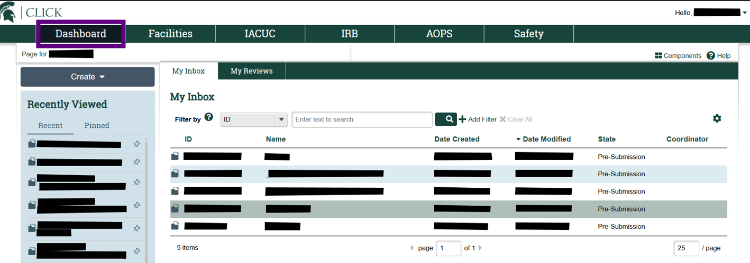
  - My Inbox shows all the submissions that require action by you or the study team.
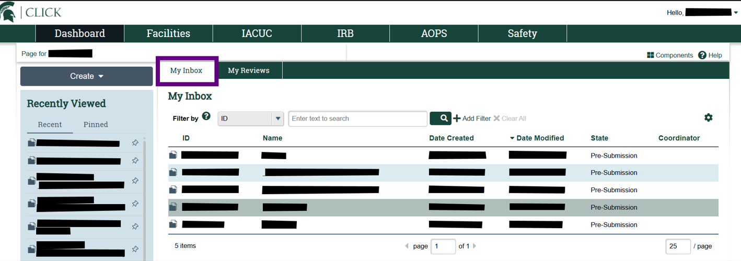
Note
- Submissions include initial studies (STUDY), modifications (MOD), continuing review (CR), modifications and continuing review (MODCR) and Report New Information (RNI).
- You can sort the columns by selecting the column title.
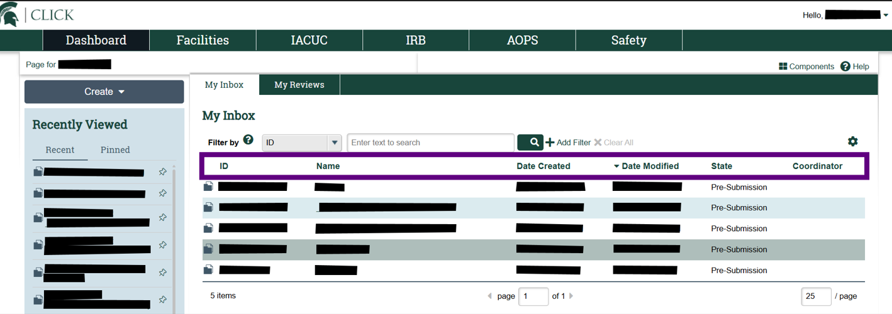

  - Locate the submission and select the ID or name (title) to open the workspace for the submission.
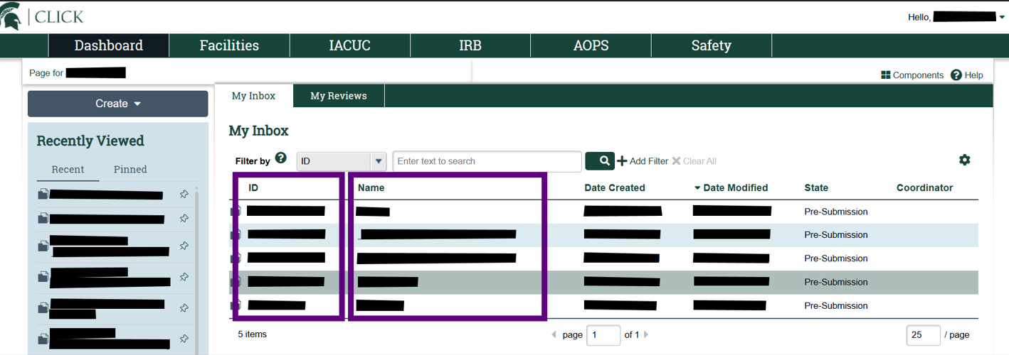

Note
- The study workspace is a workspace that is created for the initial study submission. It also includes the subsequent history of the study with links to related submissions. It is opened when you click on a submission that includes STUDY or LEGACY in the ID.
- There are separate workspaces for modification submissions (ID: MOD), continuing review submissions (ID: CR), modification and continuing review submissions (ID: MODCR) and Report New Information (ID: RNI) submissions.

  - Within the study’s workspace, you can perform required actions.
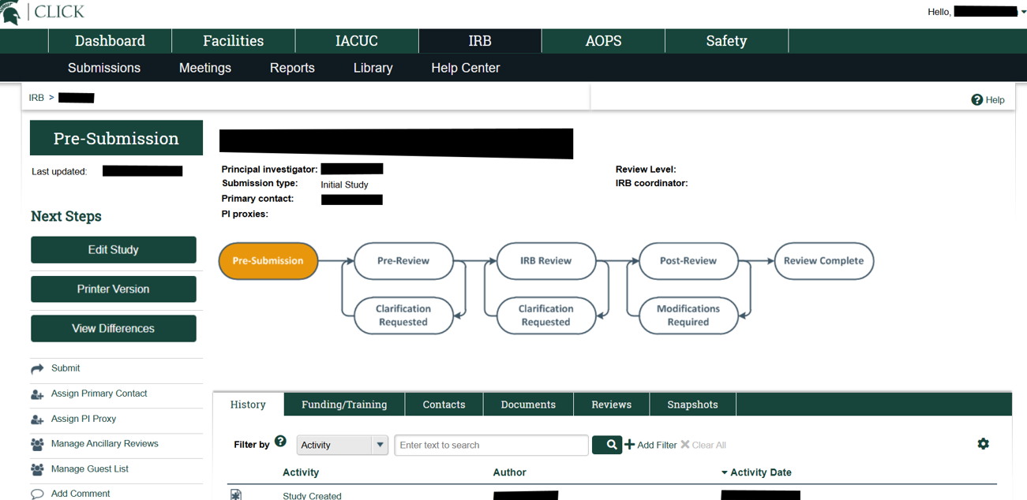

Note
- Actions required will depend on your role, the state of the study (e.g. pre-submission, clarification requested), and the submission type.

- Using IRB Tab to Navigate to All Studies or Submissions. If you need to access a study or submission that you are listed on and is not listed in My Inbox:

  - Select “IRB” from the top navigational menu.
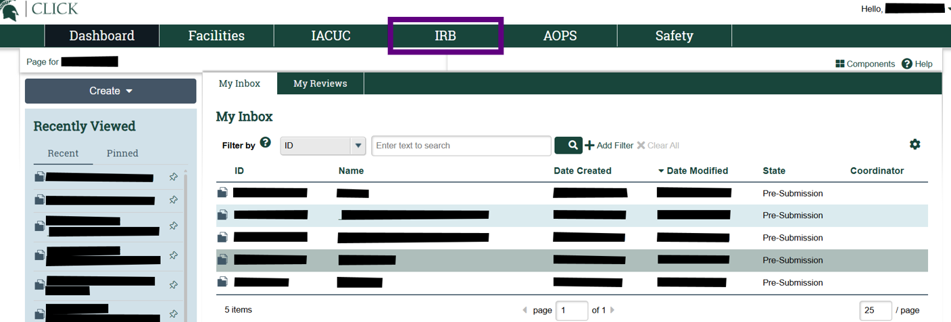

  - After you select IRB, the default view is the Submissions page displaying the In-Review tab.

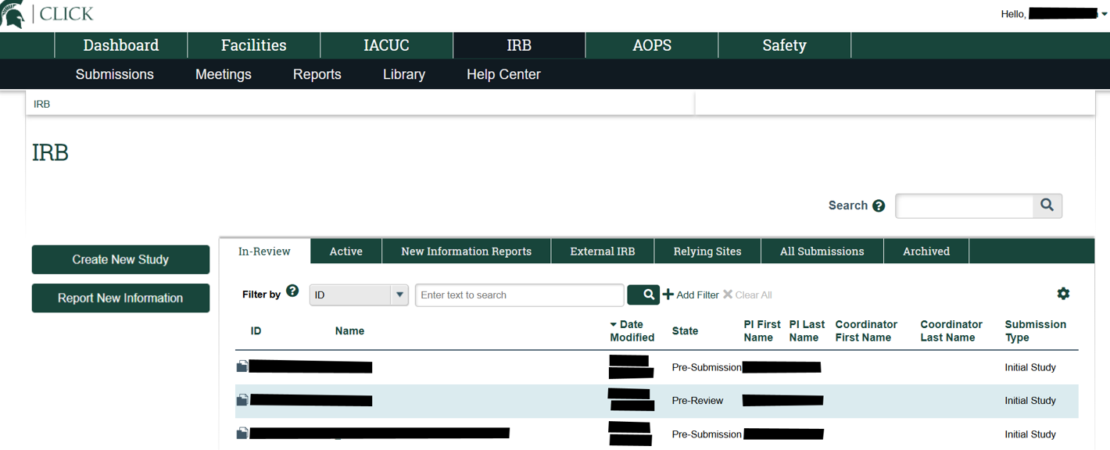

  - Select the appropriate Submissions tab:

    - In-Review. To access submissions pending action, select the In-Review Tab.
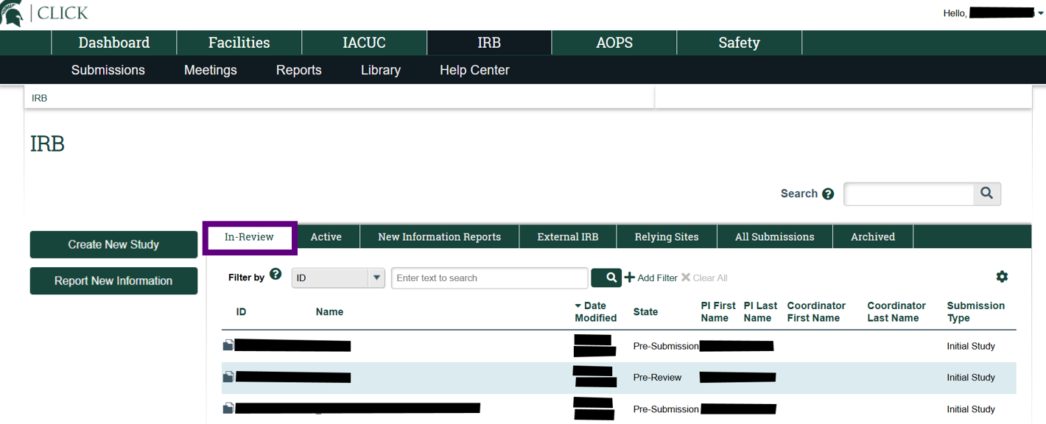

Note
- The submission could be pending action by any party (e.g. IRB, study team).
- The In-Review tab displays submissions pending action; these states include pre-submission, pre-review, non-committee review, modifications required, clarifications requested, deferred, and post-review.

    - Active. To access studies in a final state, select the Active tab.
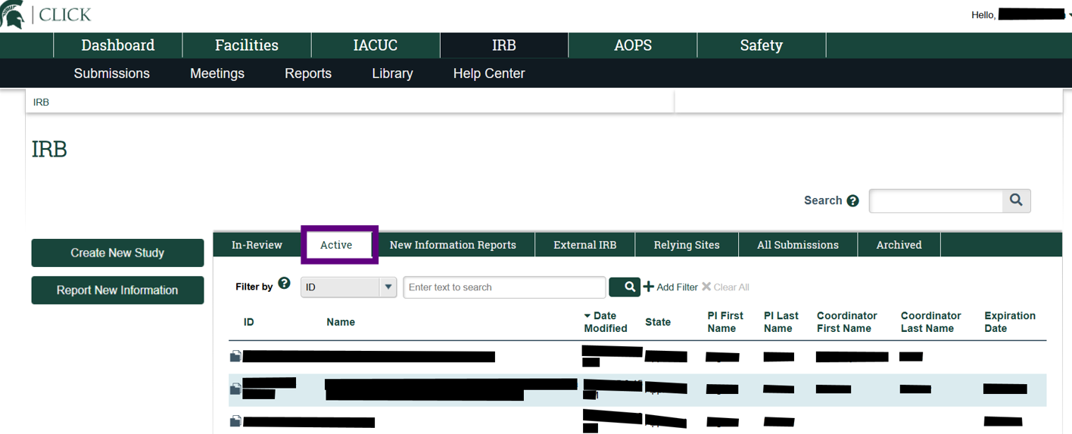

Note
- The Active tab displays submissions in a final state; these states include approved, external IRB, not human research, human research – not engaged, lapsed, and suspended.

    - New Information Reports. To access reportable new information submissions, select the New Information Reports tab.
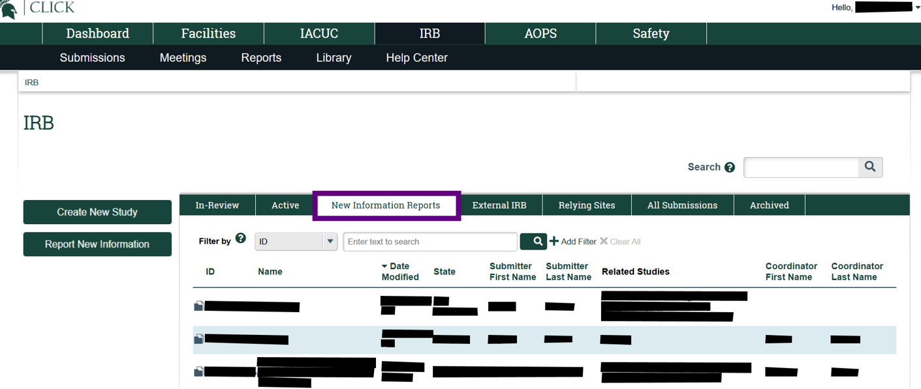
Note
- The New Information Reports tab displays Report New Information (RNI) submissions; this includes RNI submissions in various states.

    - External IRB. To access External IRB submissions, select the External IRB tab.
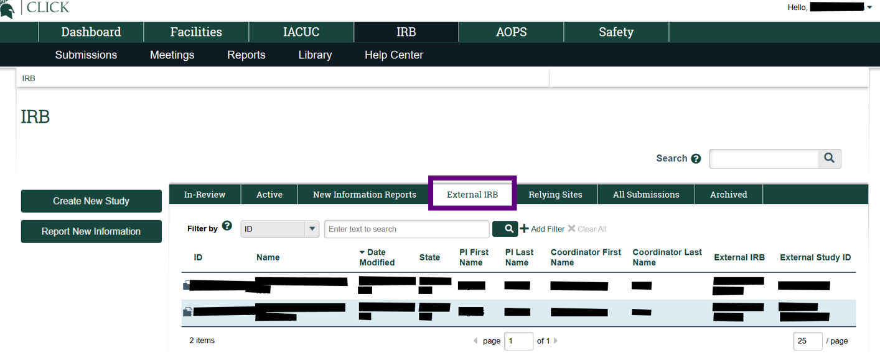
Note
  - Pending External IRB submissions will be in the External IRB tab, not in the In-Review tab.

    - Relying Sites. Please note that Relying Sites is not in use.
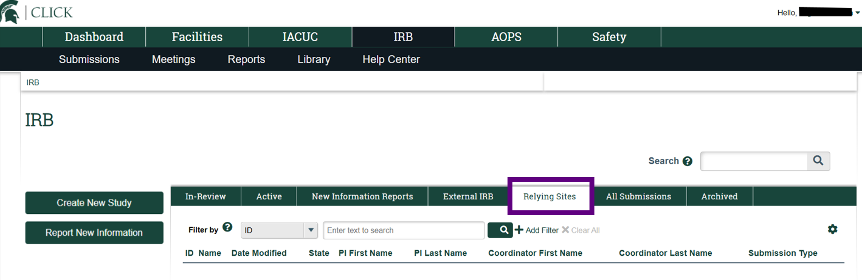

    - All Submissions. To access all study submissions, select the All Submissions tab.
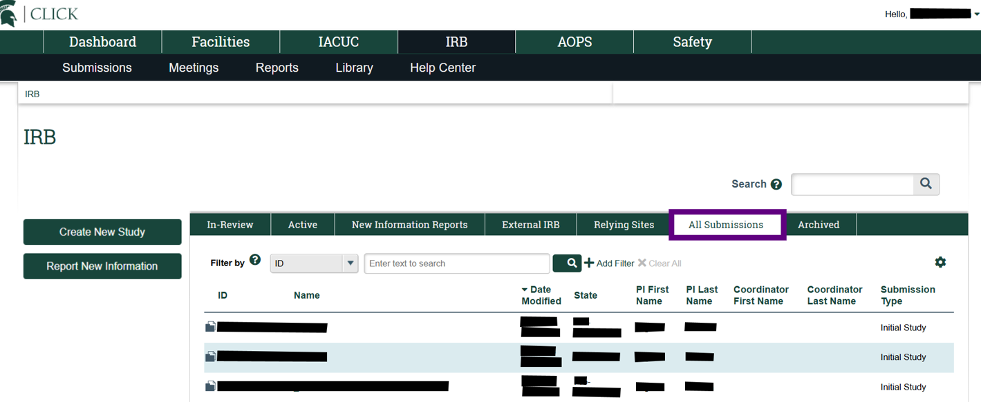

Note
- The All Submissions tab displays all of your submissions, regardless of the state; this includes all of your submissions within the system, regardless of the state it is in, including studies and new information reports.

- Archived. To access studies not in an active state, select the “Archived” tab.

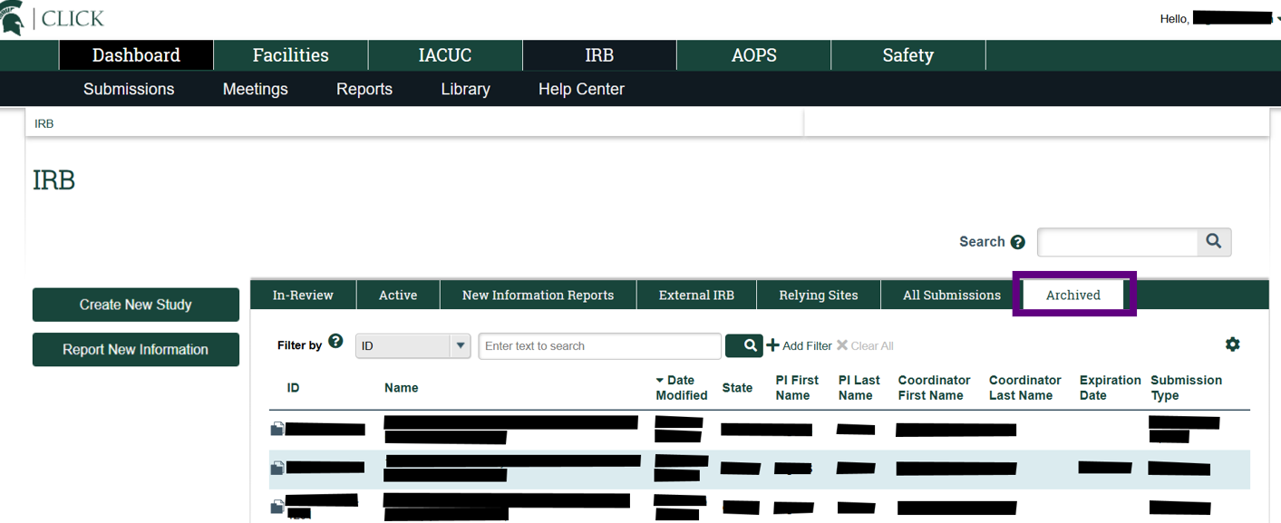
Note
  - The Archived tab includes submissions that have been closed.

- To open a study, navigate to the appropriate tab, locate the study or submission, and select the folder icon or name (title) to open the workspace.
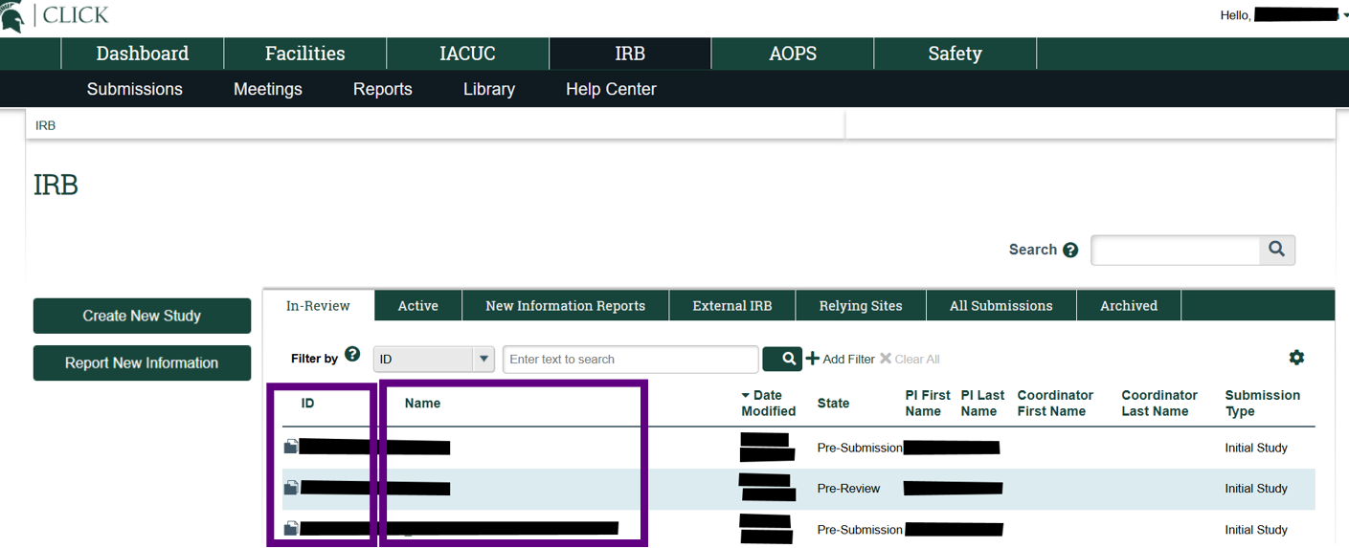

Note
- The study workspace is a workspace that is created for the initial study submission. It also includes the subsequent history of the study with links to related submissions. It is opened when you click on a submission that includes STUDY or LEGACY in the ID.
- There are separate workspaces for modification submissions (ID: MOD), continuing review submissions (ID: CR), modification and continuing review submissions (ID: MODCR) and Report New Information (ID: RNI) submissions.

- Once the workspace opens, you can perform available actions.
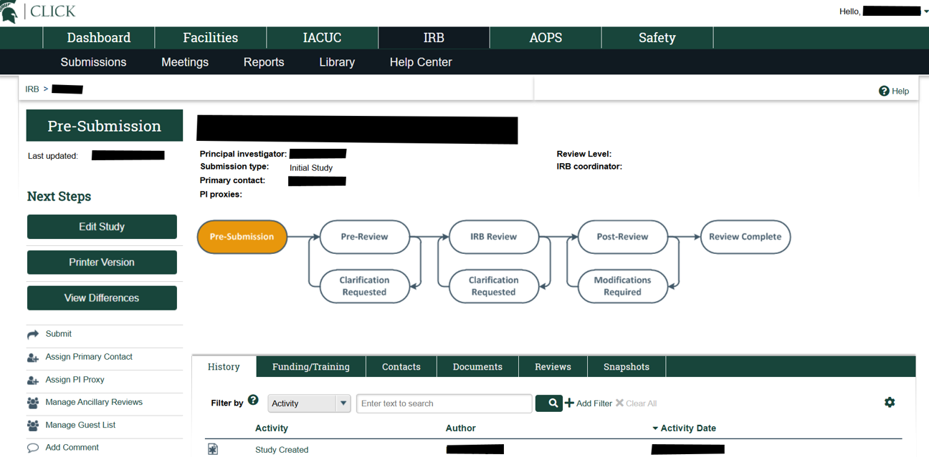
Note
- Actions available will depend on your role and the state of the study (e.g. pre-submission, pre-review, approved).

