This quick guide provides information on how to add external (non-MSU) study team members to a study.

WHO:
- Principal Investigators (PIs)
- Study Teams

WHEN:
- At the time of new study submission or modification of the study team member information.

HOW:
- Navigate to the Study Team Member page.

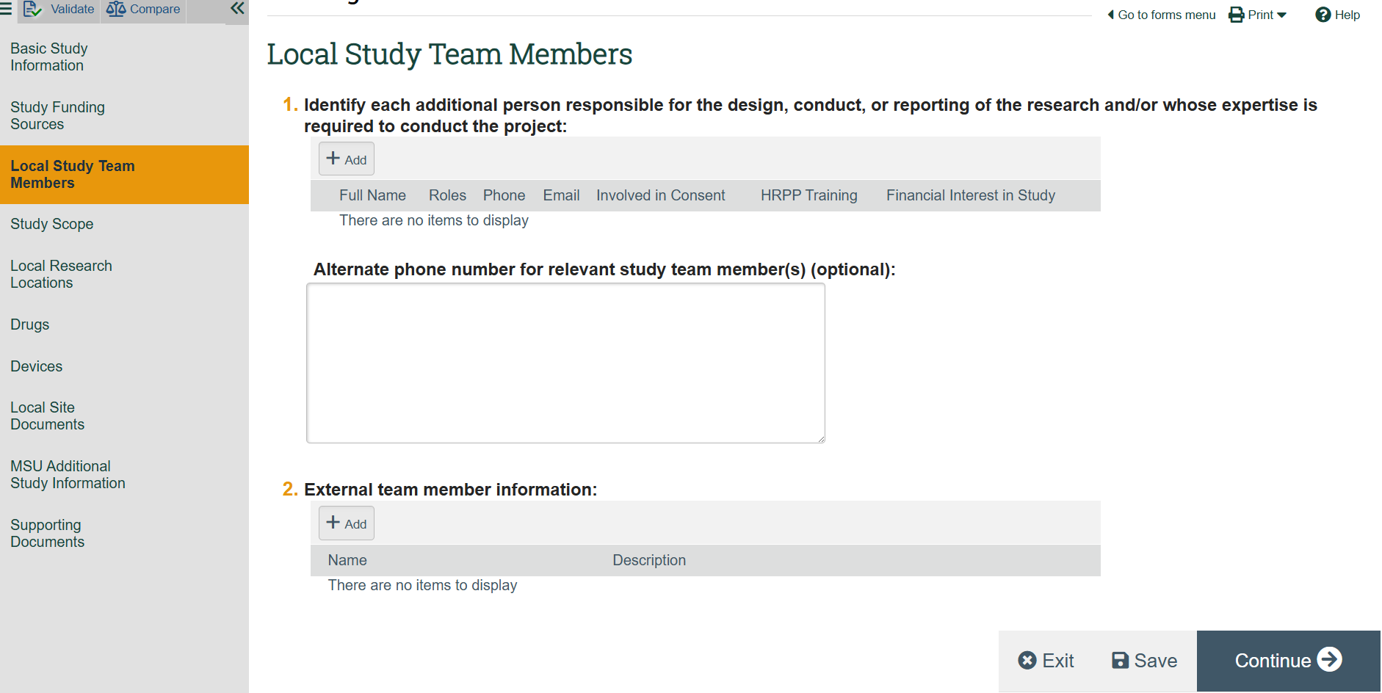

- If the external (non-MSU) individual does not require log in access to Click IRB to view or edit a study:

  - Identify external (non-MSU) study team members in a document (e.g. Word, Excel).

  - In Question 2, select “Add.”
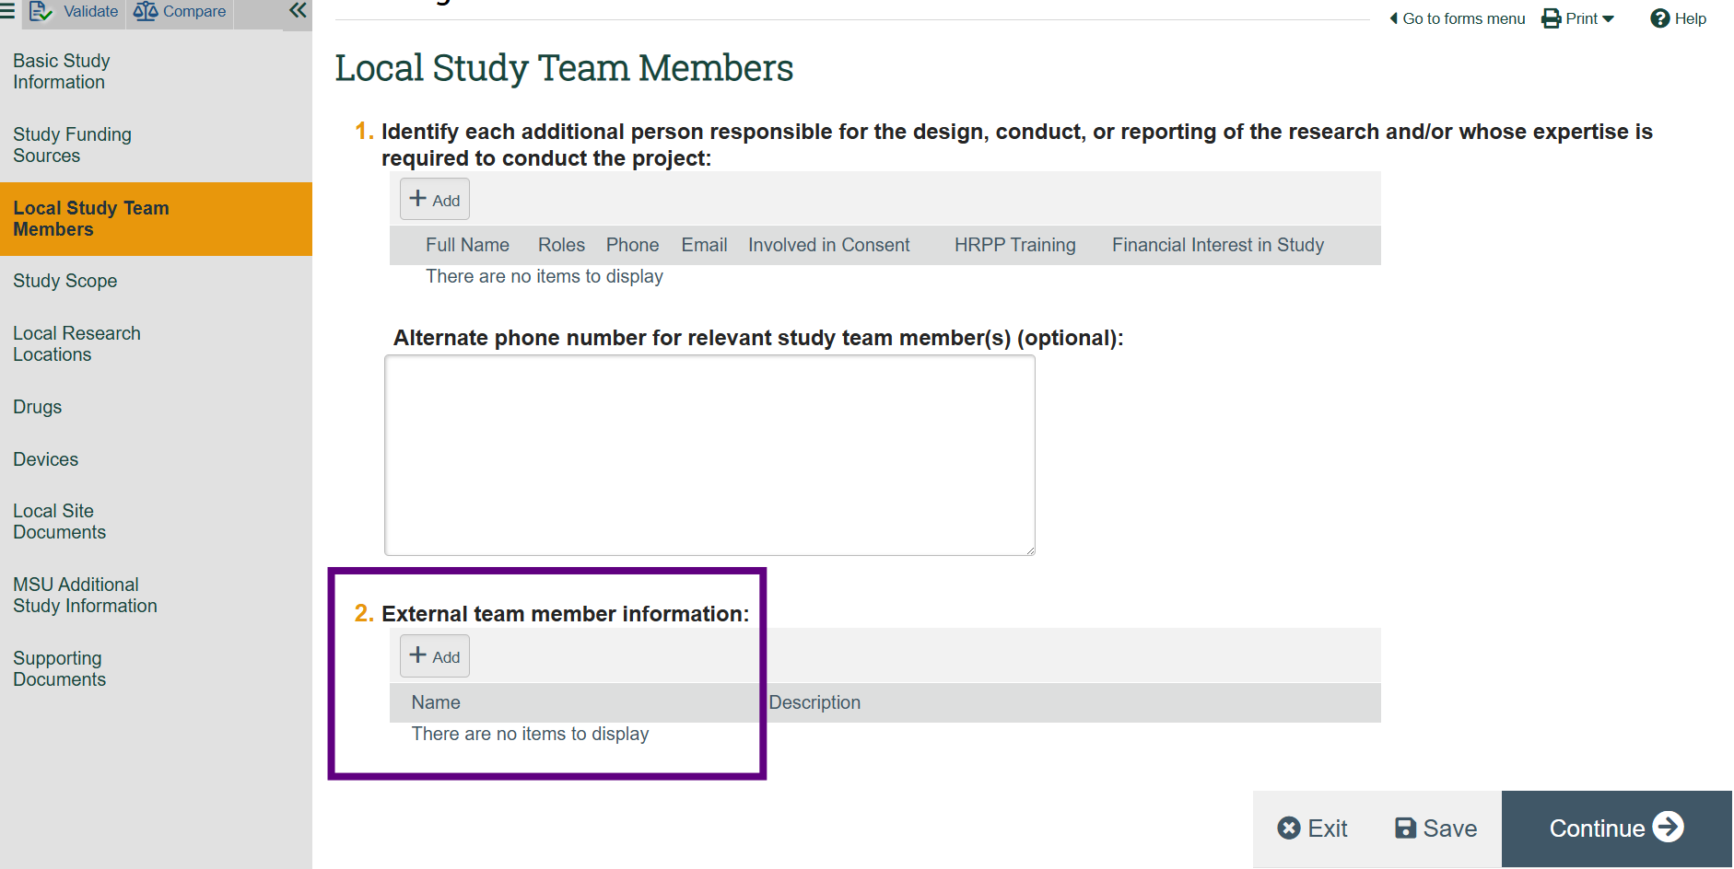
  - Upload the document.

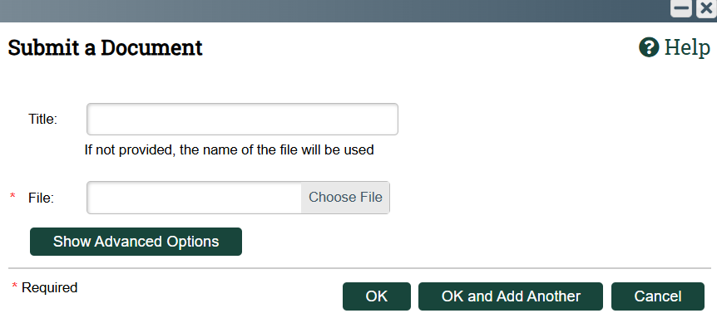
Note:
- In Question 2, External team members are listed on the study team but do not have view or edit access to the study in Click IRB.
- There is the ability in Click IRB to open and download a printer friendly version of the submission that can be provided to external team members.
- PLEASE NOTE THAT YOU DO NOT NEED TO OBTAIN A NETID FOR EXTERNAL TEAM MEMBERS. You only need to obtain a NetID if the individual requires log in access and the ability to view or edit a study in Click IRB. Otherwise, you can list external team members on the study team through the process described above.

- If the external (non-MSU) individual requires log in access to Click IRB to view or edit a study, follow the instructions provided on the MSU Office of Research Regulatory Support Click Getting Access webpage: https://orrs.msu.edu/click/access.html

Note:
- Please note that the process to obtain access to Click IRB for external team members as a Click Affiliate may take several weeks.

