This quick guide provides information on how to add a file, update a file, or view a file’s history in an IRB submission. This also includes how to remove a file.

WHO:
- Principal Investigators (PIs)
- Study Teams

WHEN:
- Adding a file, updating a file, or viewing a file’s history in an IRB submission.

HOW:
- If you need to add a file:
  - When presented with the requirement or option to add a file, select the + Add button.

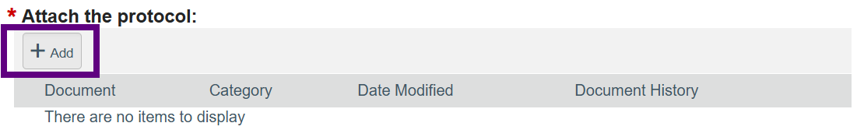
Note
- The IRB submission must be in a state that allows editing to add or update files within it, such as Pre-Submission, Clarification Requested (Pre-Review), Clarification (Designated Review), or Modification Required.

  - Select “Choose File” and choose the file to add from your file library.

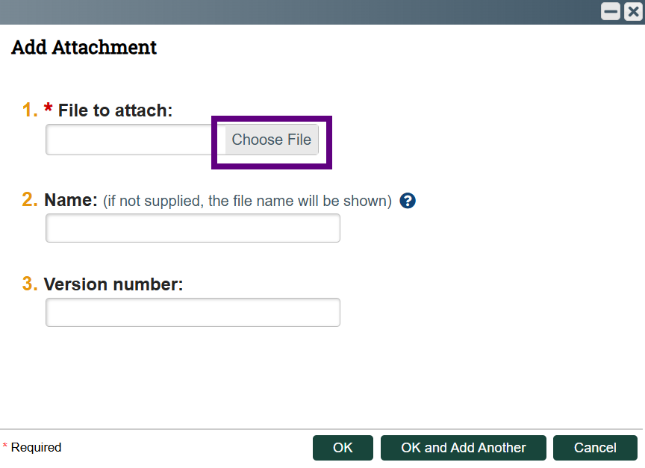

Note
- Examples of file types that can be added include MS Word, PDF, JPG, PNG, and MP3.
- If you have difficulty uploading a file based on the type or size, please contact the Click Help Desk at clickhelpdesk@msu.edu or 517-355-2000.

  - Optional: Enter a file name, if you so choose.

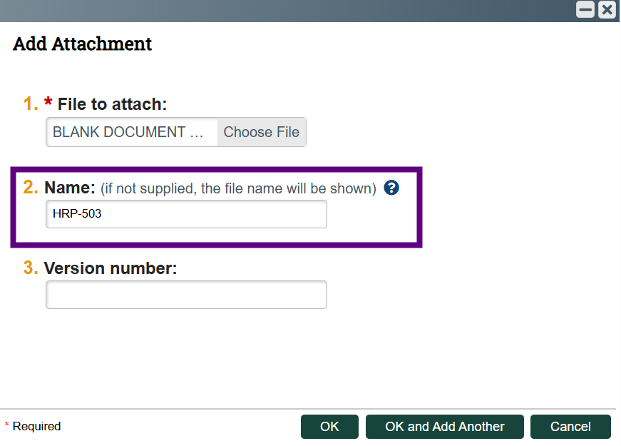
Note
- If you do not enter a name, the name will default to the file name.

  - Optional: Enter a version, if you so choose.

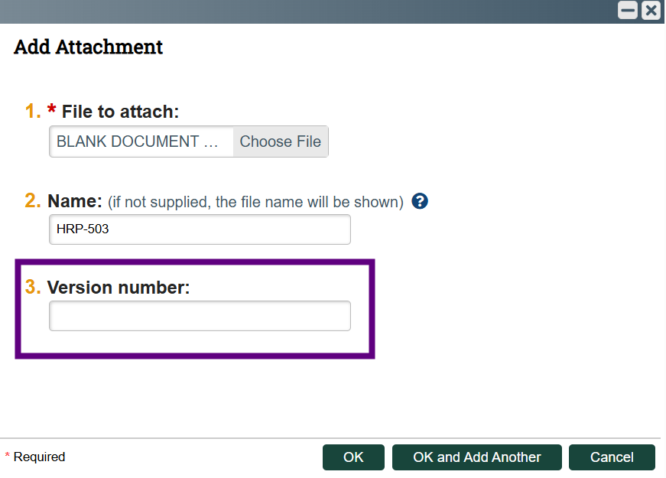
Note
- If you do not enter a version, the system will automatically version the file.

  - Optional: If you have more than one file to add, you can select OK and Add Another button to add more files. Continue until you have added all files.

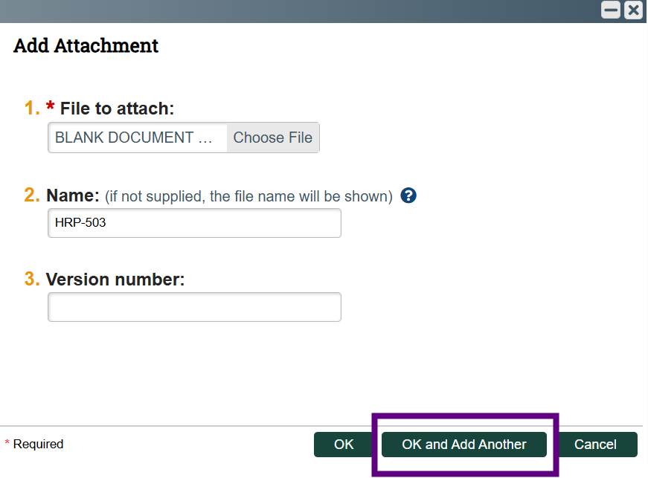

  - Select the OK button to complete the Add Attachment action.

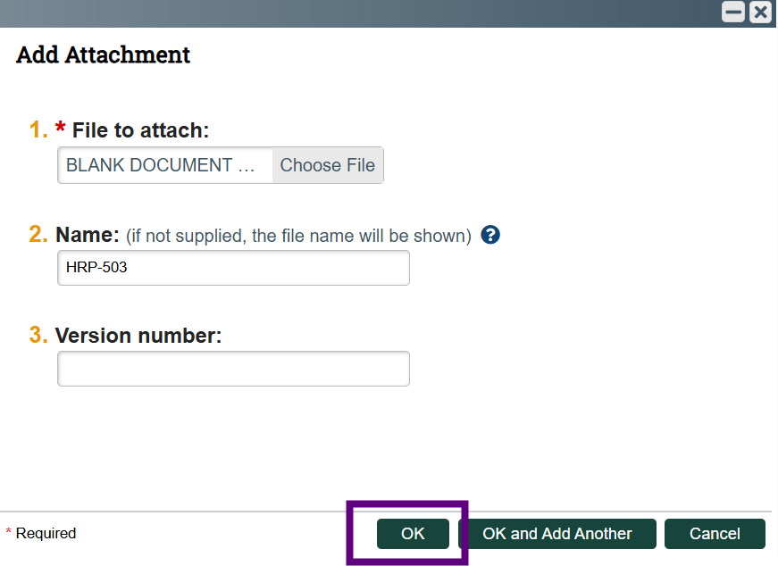

  - After a file is added, the system will populate with the file name and version, category, date modified, and a link to file history.

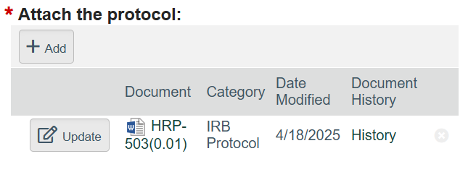
Note
- Category populates based on where the file is uploaded within the IRB submission. You may be asked to select a category for some file uploads.
- Date Modified populates with the date the file was added.
- You can add more files by selecting the + Add button.

- If you need to update a file:
  - Locate the file you would like to update (if there is more than one file), and select the Update button next to the file name.

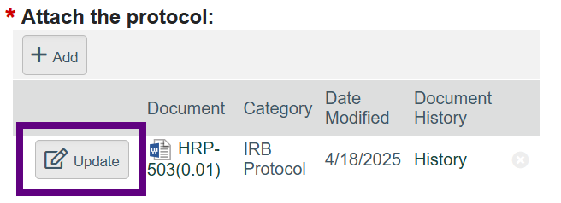

  - After you select Update, you are able to replace the file. Select the Choose File button to choose the updated file, enter name and version number (if you so choose), and select the OK button.
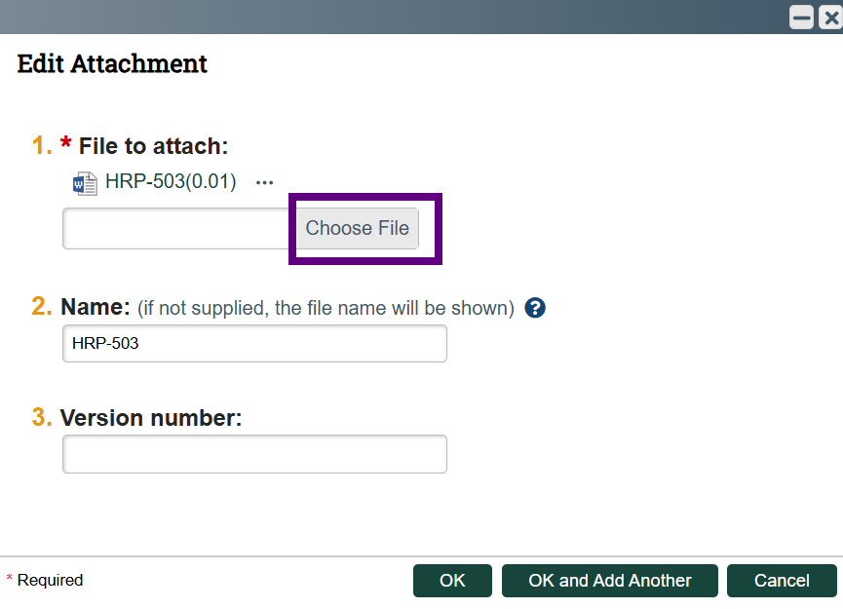

- If you need to remove a file, select the x button to the right of the file information.

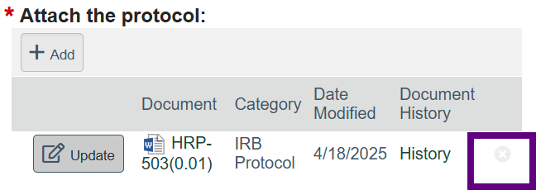

- If you would like to view the file history:
  - Locate the file you would like to view history of (if there is more than one file) and select the History link under Document History.

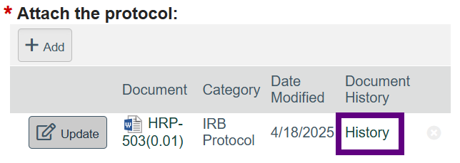

  - The history of the file displays.
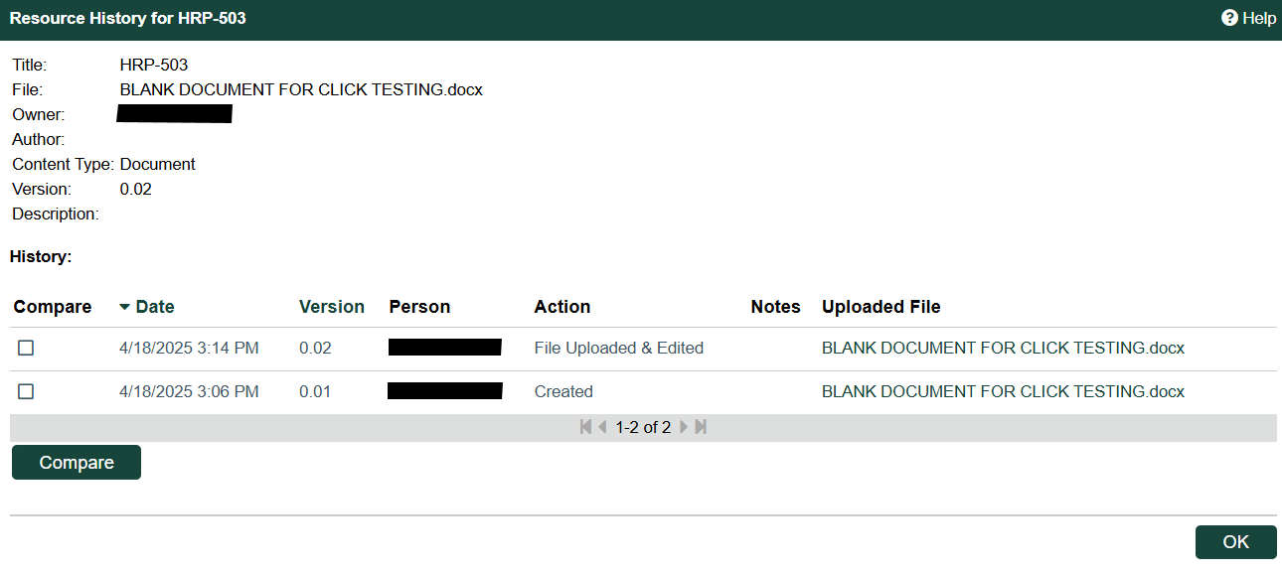
  - The history includes links to previously uploaded files (if any). Select the uploaded file link to view the file.
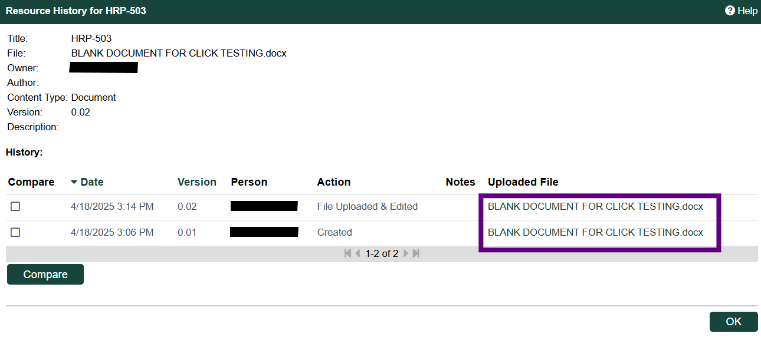

  - You may also perform a document compare by selecting the checkboxes in the Compare column and then selecting the Compare button.
