This quick guide provides information about how to create, save, and edit an initial study.

WHO:
- Principal Investigators (PIs)
- Study Teams

WHEN:
- Creating, saving, and editing an initial study.

HOW:
- Click on the “IRB” tab.

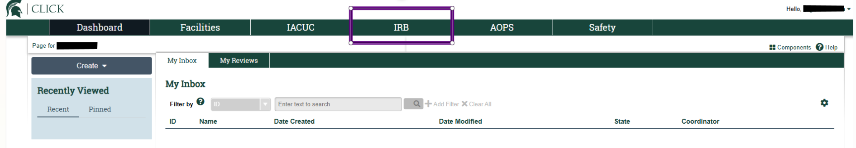

- Click Create New Study.

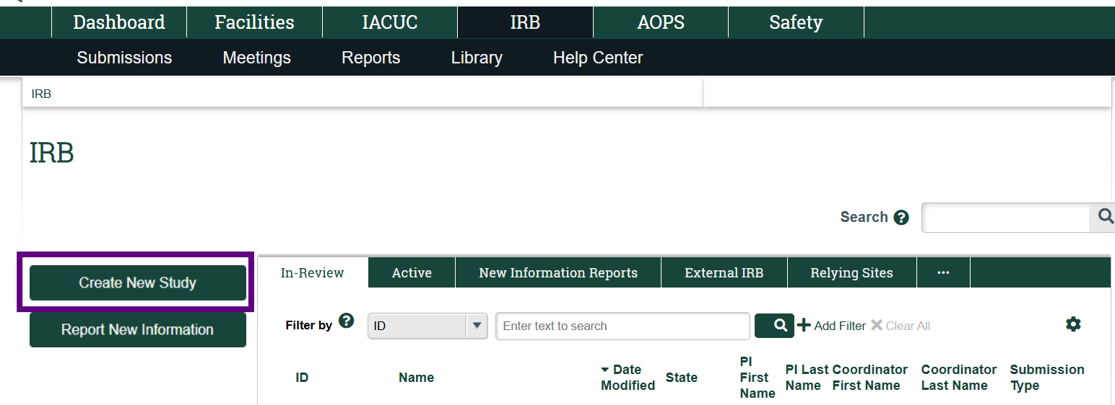

- On the Basic Study Information page, complete the required fields (indicated with a red asterisk: *).

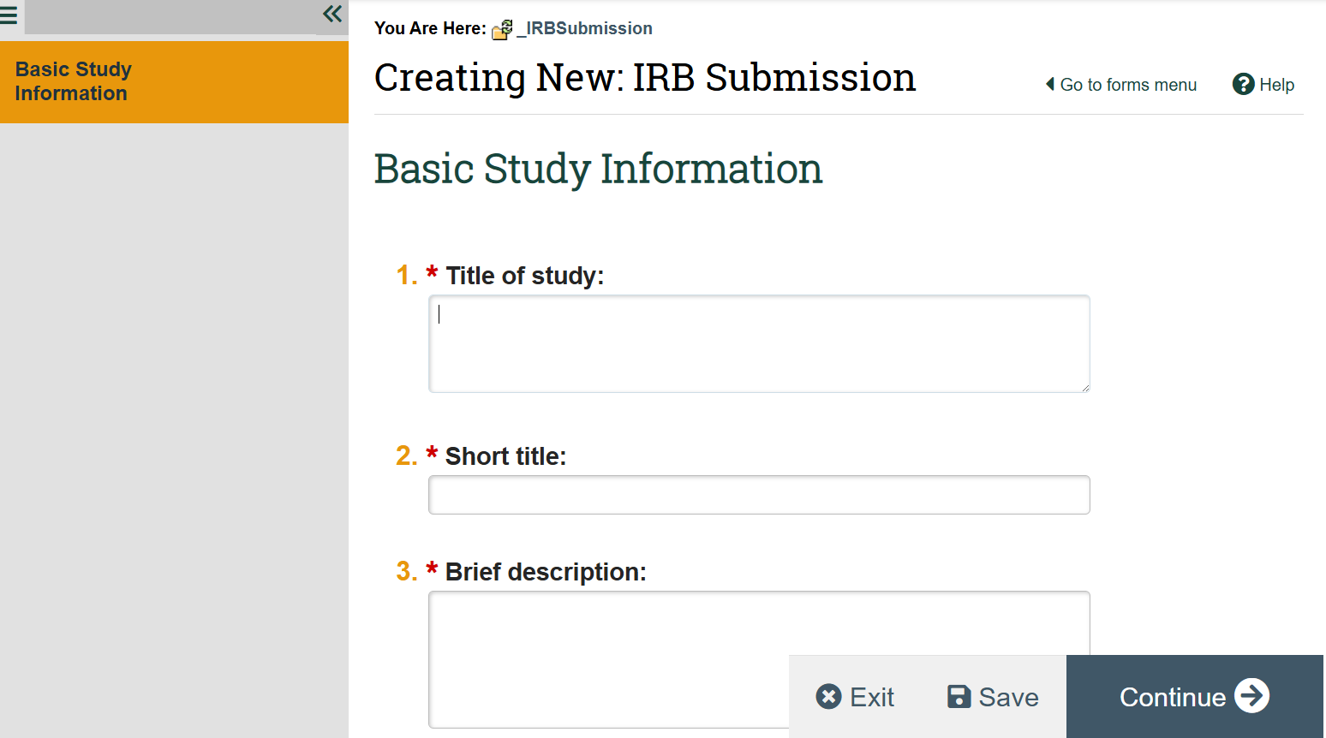

Note:
- Question 6 defaults to listing the individual that started the study as the Principal Investigator (PI). If this question requires updating, select the ellipsis: “…” and a window will appear to select the new PI. If you update the PI, be sure to add yourself to the Study Team so that you maintain edit access to the study.

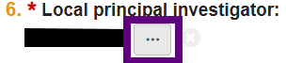

- Question 11 requires a protocol. Visit the HRPP What and How to Submit webpages for information about what protocol to include: https://hrpp.msu.edu/help/submit/index.html

- You can select “Save” to save the information you have entered.

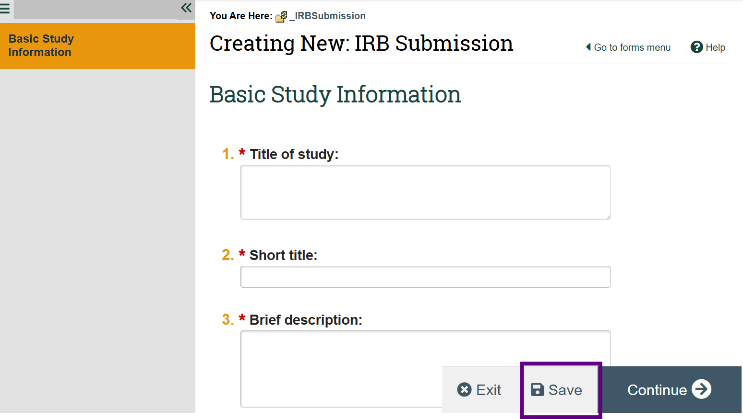
Note:
- For the Basic Study Information page, you must complete questions 4, 5, 6, and 11 to save the study using the Save button. If you select the Continue button, you must complete all required fields.
- After saving the study, a Study ID is assigned and additional navigational features appear including the additional application pages in the left navigational menu and a Print button in the upper right.

- You can proceed through the application pages using the “Continue” button or selecting the application page in the left navigational menu.

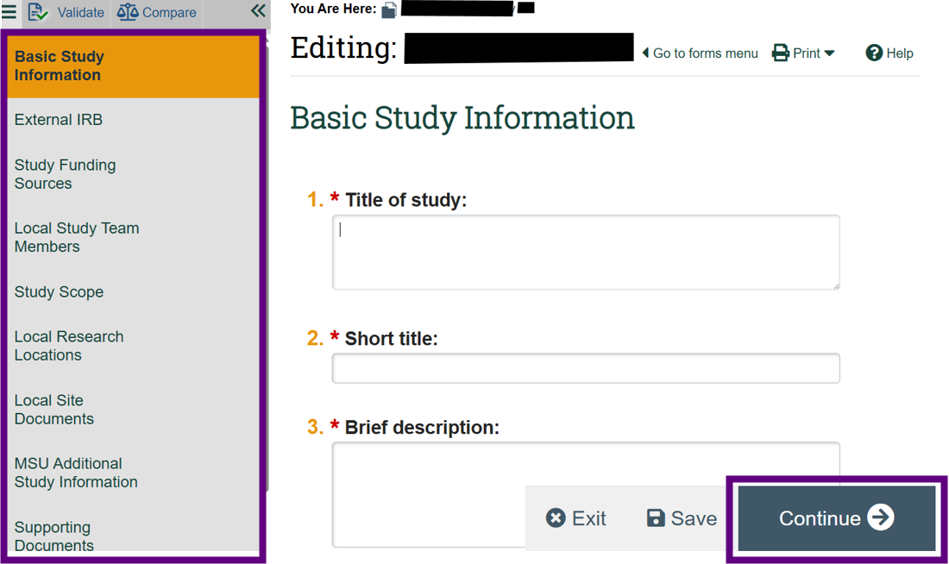

Note:
- Answer each required question within each application page. Select the Continue button or select another application page (in the left navigational menu) when you are ready to proceed. This will save the information entered.
- If you use the left navigational menu, you can leave required questions blank and return to them later.
- If you select Continue to navigate to the next application page, you must complete all required questions to Continue.

- If you need to clear an answer selected, select Clear.

This will clear the answer selected:
- If you would like to view the required fields that still need to be completed, select the Validate option in the left navigational menu.
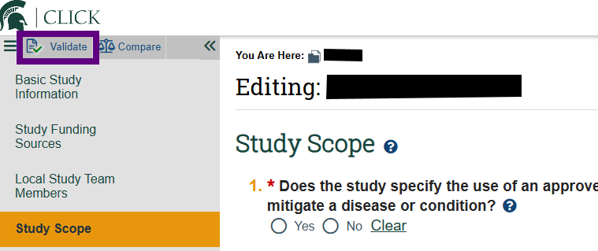

  - In the left navigational menu, a green check mark icon will display for application pages where all required questions have been completed. A red error circle icon will display for application pages where all required questions have not been completed, along with which questions still need to be answered.
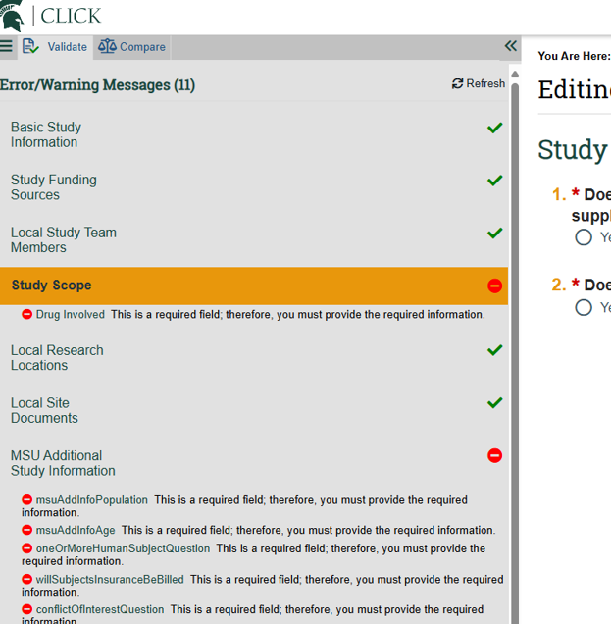
  - You can turn off the validation by selecting the three lines menu icon in the upper left navigational menu.
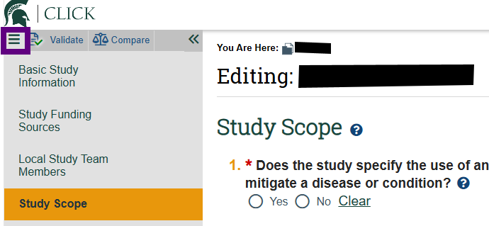

- To exit the application, select the Exit button.

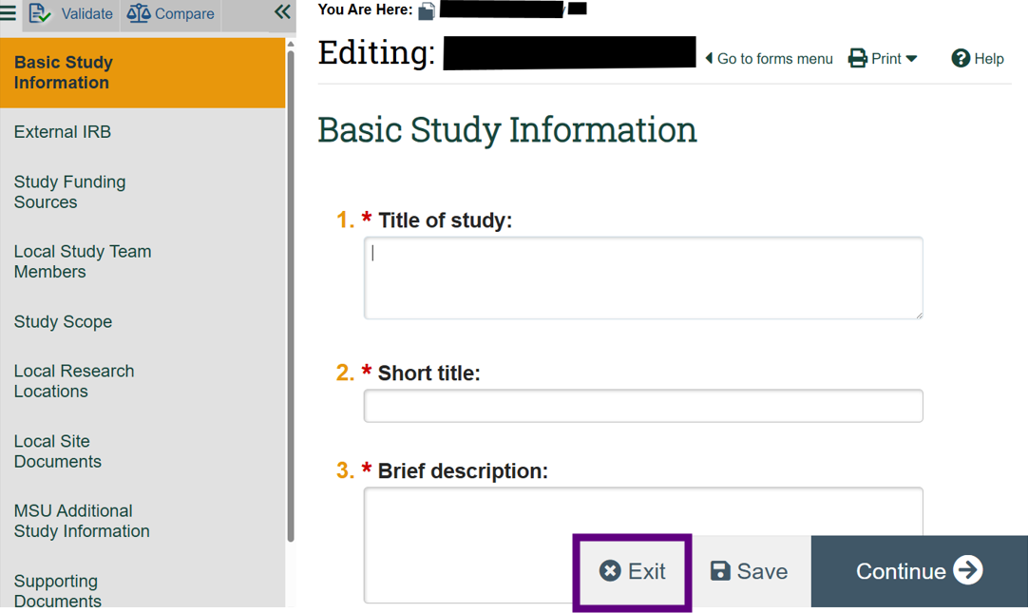

- If you select Exit and have not saved changes, you will be asked to select whether you want to Save Changes & Exit, Ignore Changes & Exit, or Cancel. Select appropriate option.
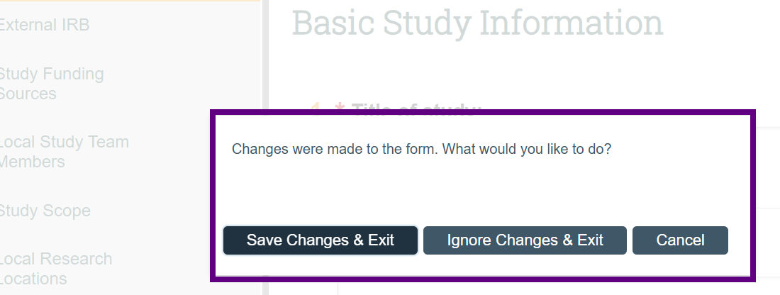

- After you exit the study, you will be returned to the study’s workspace. The workspace is where you can view the study, available actions and history are displayed, documents can be accessed, and other information about the study is provided.
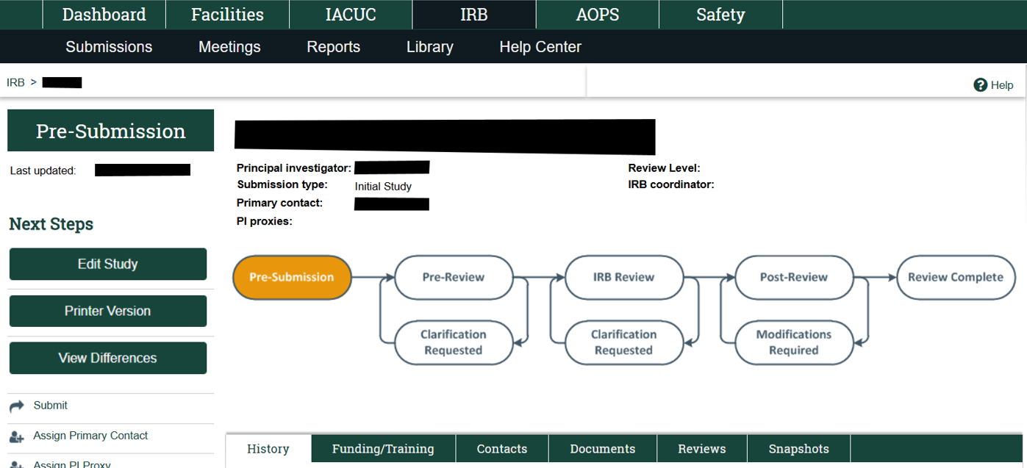

- To edit the study, select the “Edit Study” button on the study’s workspace.
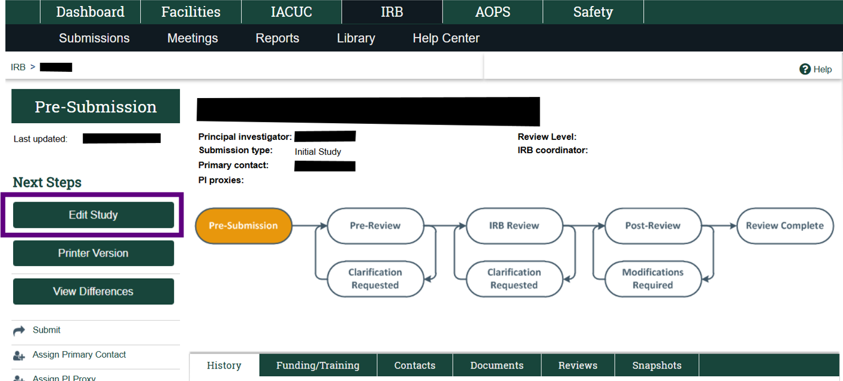
Note:
- The edit button will be available to the study team until the study is submitted.
- The study will stay in a “Pre-Submission” (editable) state until the study is submitted.

