This quick guide provides information about how to Report New Information (RNI) in Click. Examples of reportable events include unanticipated problems involving risks to subjects or others, subject complaints, potential noncompliance, etc.
DO NOT INCLUDE ANY INDIVIDUALLY IDENTIFIABLE SUBJECT INFORMATION IN THE REPORT. THIS INCLUDES PROTECTED HEALTH INFORMATION AS DEFINED BY THE HEALTH INSURANCE PORTABILITY AND ACCOUNTABILITY ACT (HIPAA), INCLUDING HIPAA IDENTIFIERS (See HRPP Manual 7-6 Health Insurance Portability and Accountability Act Compliance in Human Research for more information).
For urgent situations, please call 517-355-2180. For more information on reportable events, please visit the HRPP Manual (https://hrpp.msu.edu/msu-hrpp-manual-table-contents-expanded).

WHO:
- Principal Investigators (PIs)
- Study Teams

WHEN:
- Creating and submitting Reportable New Information (RNI)

HOW:
- Click on the “IRB” tab.

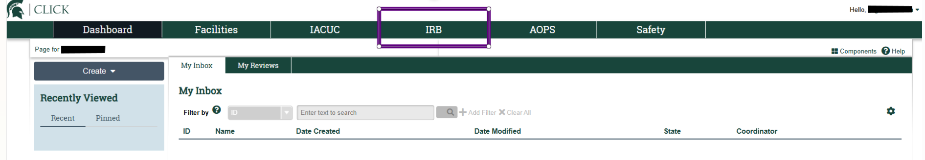

- Click Report New Information.
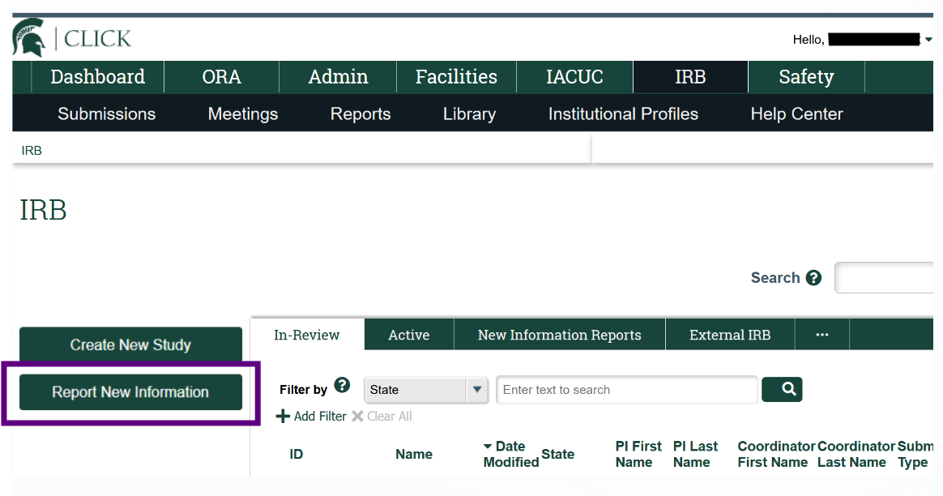
Note: You can also Report New Information from a Study’s Workspace.

On the Reportable New Information submission page, complete the questions. Included in the table below are the Report New Information questions.
Question Number | Question | Required? | Answer Options
1 | RNI short title (uniquely identify this new information report) | Optional | Open ended text box
2 | Date you became aware of the information: | Required | Date entry
3 | Identify the categories that represent the new information: (check all that apply) | Optional | Choose selection(s) (check all that apply):  - Potential unanticipated problem that may involve risk to subjects or others  - Potential or confirmed noncompliance with a federal or state law, regulation, policy or the requirements and/or determinations of an IRB  - Subject complaints  - Unapproved change in protocol to eliminate a hazard to subjects  - Protocol deviations or violations: Any change, divergence, or departure from the study design or procedures of a research protocol that has not been approved by the IRB  - Suspension or termination: Premature suspension or termination of the research by the sponsor, investigator, or institution.  - MSU HRPP Compliance Office TEACH  - MSU HRPP Compliance Office Site Visit  - Audit or inspection by a federal or state agency  - New potential conflict of interest of a study team member  - Written reports of study monitors  - Emergency use of investigational drugs or devices  - Any activities or circumstances that affect the rights and/or welfare of research subjects  - Any information that could increase the risk to subjects
4 | This system is not able to store any information that identifies research participants. Do not enter or upload any information that identifies research participants. Do not upload signed consent documents, names of research participants, emails with research participant names, etc. Please check the box to confirm that this RNI submission will not include any identifiable information about research participants. Please contact the IRB office with questions. | Required | Check box
5 | Briefly describe the new information: | Required | Open ended text box
6a | In the submitter's opinion: Does this information indicate a new or increased risk, or a safety issue? | Required | Choose 1 selection:  - Yes  - No
6b | In the submitter's opinion: Does the study need revision? | Required | Choose 1 selection:  - Yes  - No
6c | In the submitter's opinion: Does the consent document need revision? | Required | Choose 1 selection:  - Yes  - No
7 | Related studies and modifications: | Optional | Predefined list of study(ies) to select from based on role
8 | Attach files containing supporting information: | Optional | Upload file attachment(s)

Note:
- DO NOT INCLUDE ANY IDENTIFIABLE SUBJECT INFORMATION IN THE REPORT.
- Question 7: Be sure to identify the specific study(ies) that this reportable event is related to, if known or any.
- Question 8:
  - If the RNI may be an unanticipated problem involving risks to subjects or others, complete and attach HRP-531 – Template – Unanticipated Problem Involving Risk to Subjects or Others
  - If the RNI may be a protocol deviation or violation, complete and attach HRP-532 – Template – Protocol Deviation or Violation
  - If the RNI is a subject complaint, complete and attach HRP-533 – Template – Subject Complaint.
  - If the RNI is reporting emergency use of investigational drugs or devices, complete and attach HRP-534 – Template – Emergency Use of Investigational Drugs or Devices.

- You will need to return to the RNI submission’s workspace to submit the RNI (select Exit or Continue).
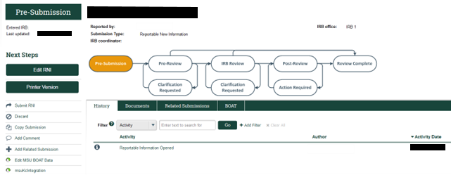

- Select Submit RNI to submit the Reportable New Event to the Institutional Review Board office. Only the individual who created the RNI can perform the “Submit RNI” activity.
