This quick guide provides information about how to submit an initial study. Only the Principal Investigator (PI) or PI Proxy(ies) can submit an initial study.

WHO:
- Principal Investigators (PIs) or PI Proxies

WHEN:
- Submitting an initial study.

HOW:
- The PI, PI Proxy(ies), and/or study team completes the application pages for the initial study. The Final Page displays when you are on the last application page (Supporting Documents) and you select Continue.

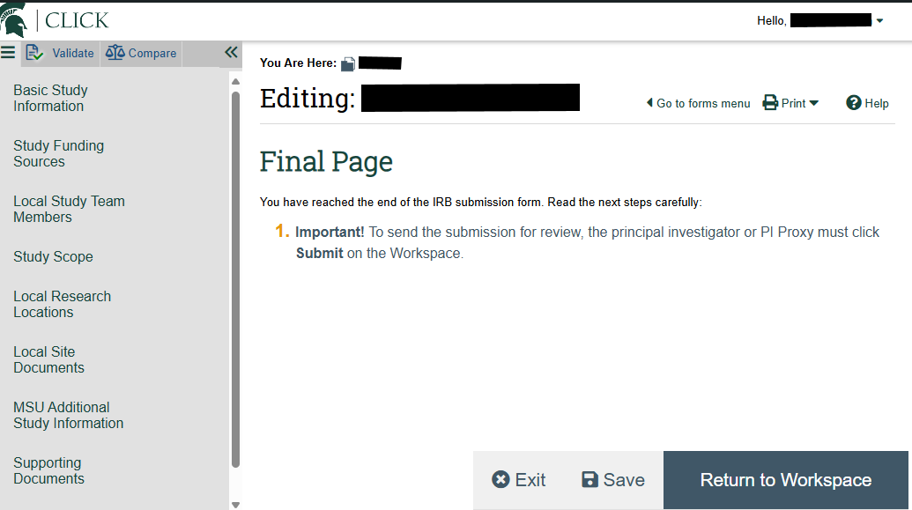
Note
- For more information about how to create, save, and edit an initial study, please see Quick Guide: How to Create, Save, and Edit an Initial Study.

- Select “Return to Workspace.”

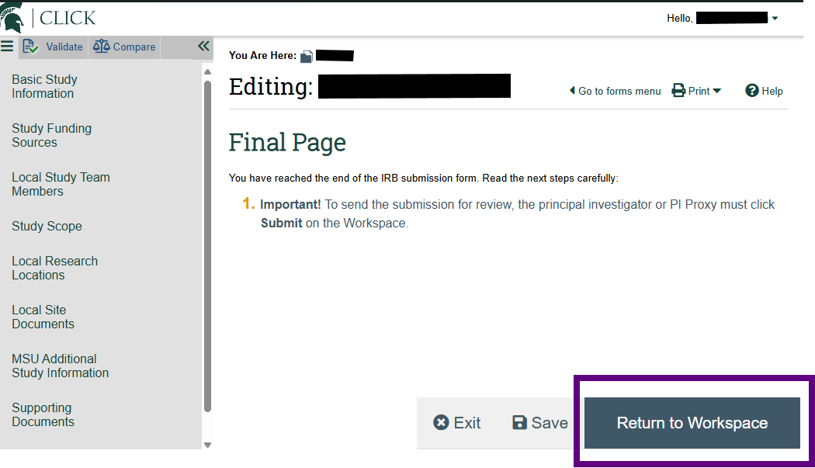
Note
- Selecting Return to Workspace will not submit the study; the submit action on the study workspace still needs to be performed.
- Selecting Return to Workspace will exit the application and return you to the study workspace.
- You can also select Exit to exit the application and return to the study workspace.

- Select “Submit” on the left side menu. The Submit action will only be displayed to the PI or PI Proxy(ies). The Submit action is not available to other study team members on the study workspace.

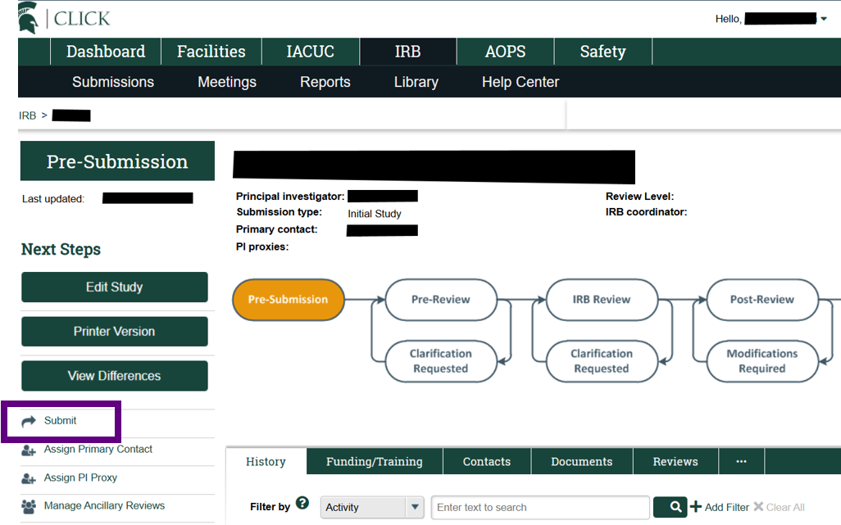

- Review the Principal Investigator verification and select the ‘OK’ button.

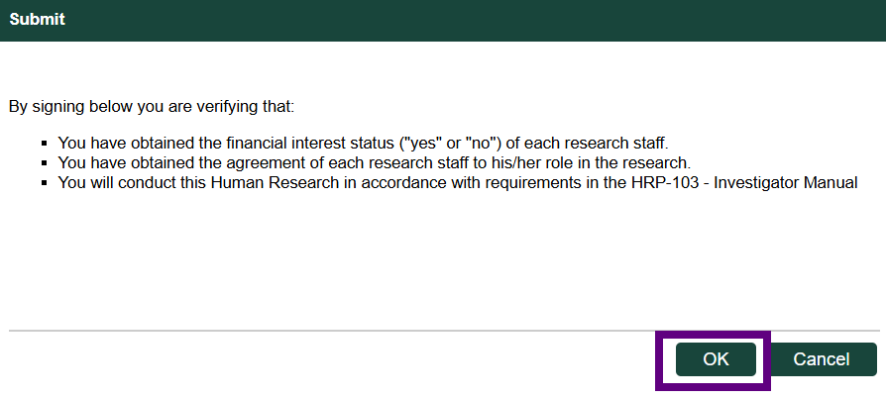

- The study has now been submitted to the IRB office for review.

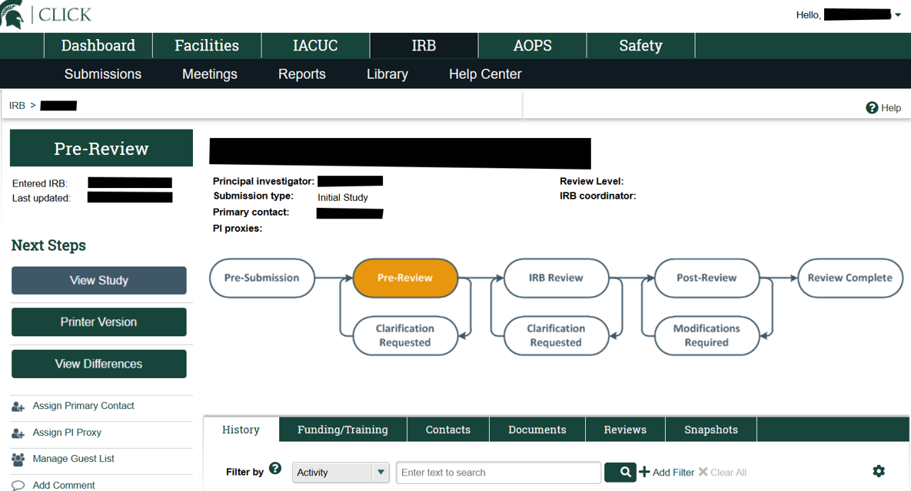
Note
- The study is now in the Pre-Review state.
- The study is not editable in the Pre-Review state.

